**STATUS_REPORT: 03/17 to 03/31**

* Start with the SJone Gateway board by following Garurav’s document.

<https://docs.google.com/document/d/15OVILY2tH6Kwb_Gw3jHjR65Salk6FJFDp7excOwskS0/edit>

* Ran a sample code for measuring the proximity distance “B-L475E-IOTA” on the STM Discovery kit.
* Next step is to run a discovery kit code “B-L475E-IOT” for sending the on-board sensor data to the AWS. Following steps were executed for transferring the data to the AWS

1. Create an amazon AWS account if you don’t have. Complete all the steps required for the signup. Please provide your card details. Create it with AWS account at the following link: <https://aws.amazon.com/>
2. Type IAM in the search window and click on that

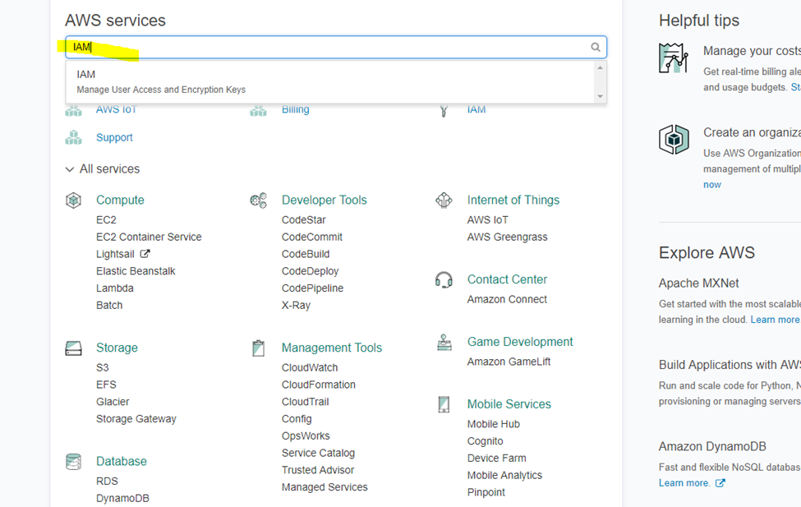

1. On IAM service click on group name and add group name. I had added AWS_IOT_Vatsal. Attach the AWSIoTFullAccess policy to the group

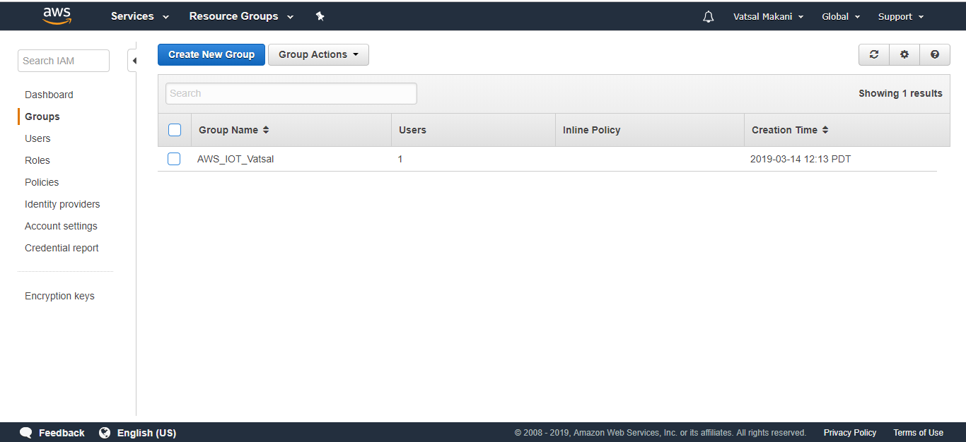

1. Click on user and add user with permission “access type = programmatic access” and add the users to the group. I have added username- VatsalMakani

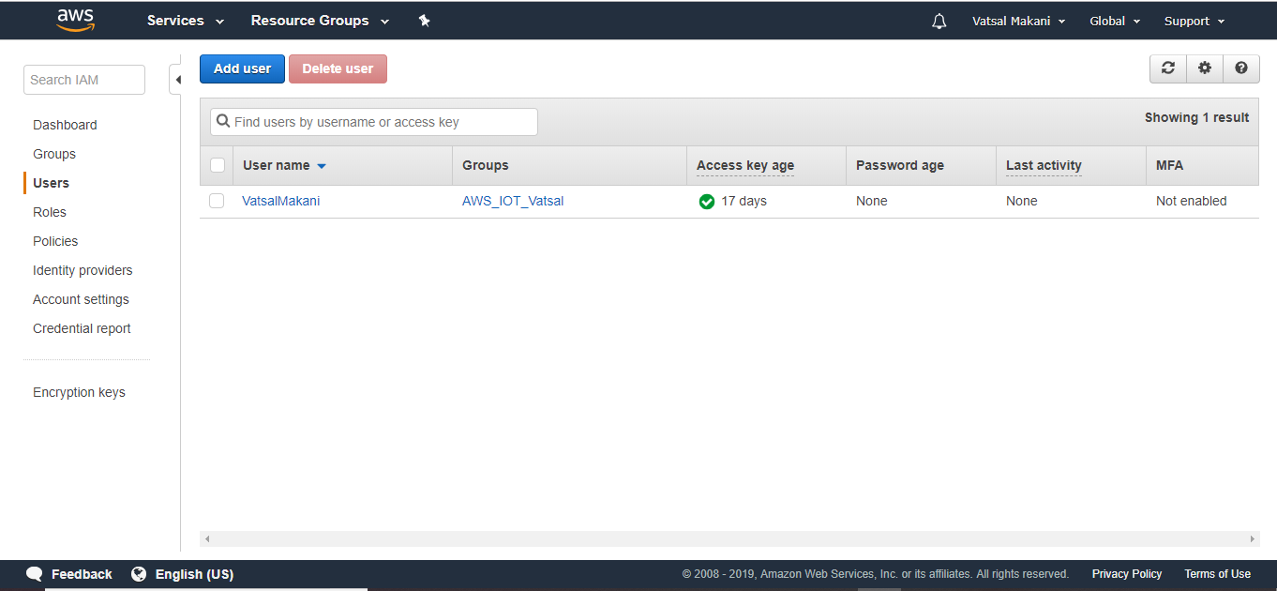

1. Go to Services tab and select IoT Core

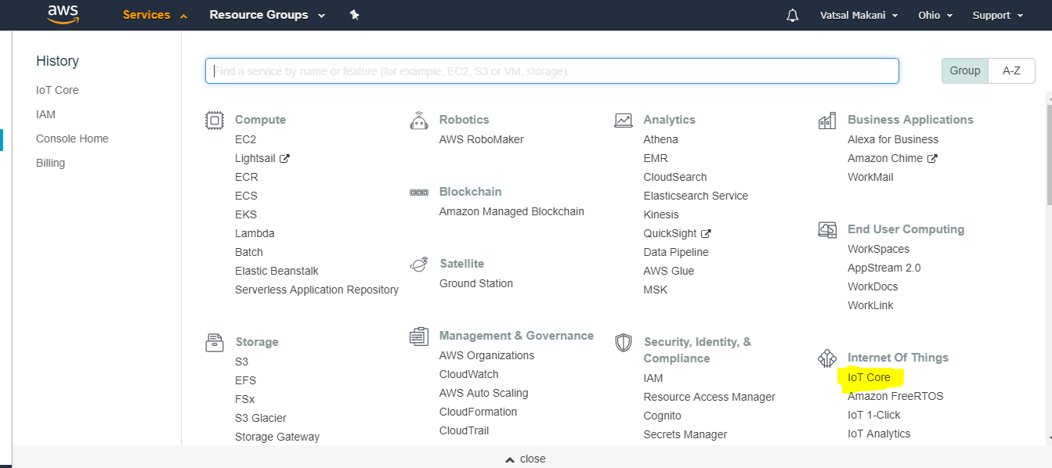

1. Go to Manage🡪 Things🡪 Create a thing. Name it as IoT_Things

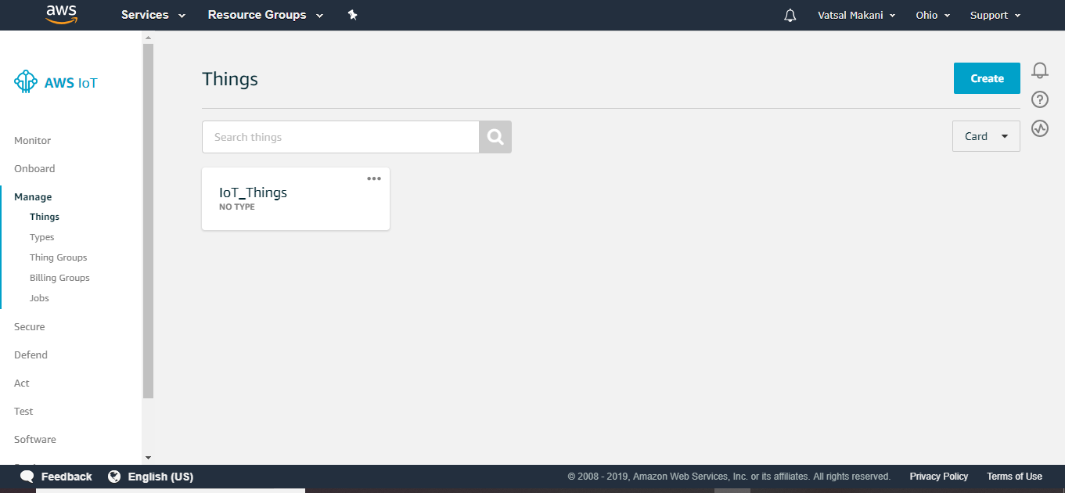

1. Click on Iot_Things. Go to Security --> Create Security

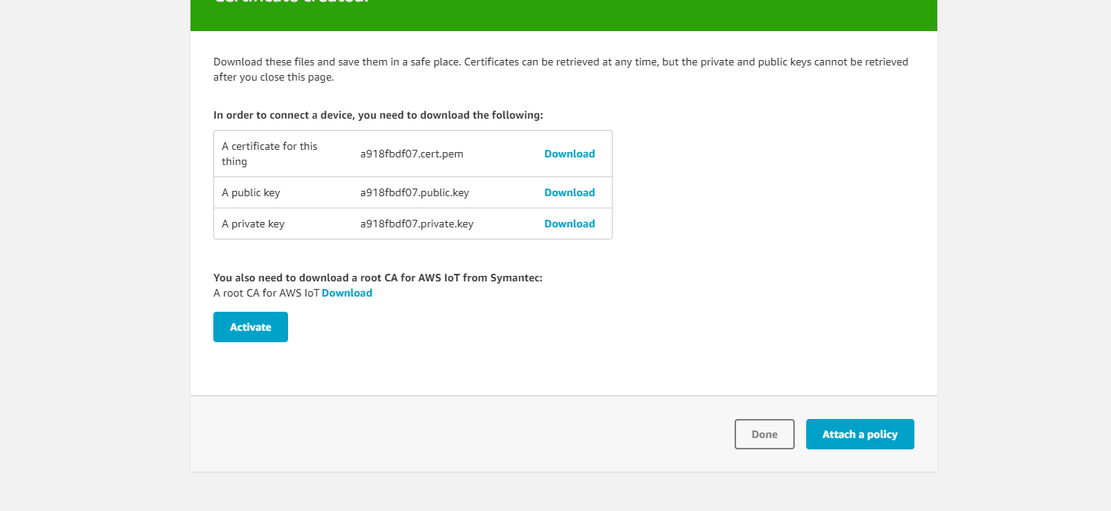

And download the .cert.pem, private key ,public key and root CA certificate.Click on activate.

1. Attach the policy to the certificate

{

"Version": "2012-10-17",

"Statement": [

{

"Effect": "Allow",

"Action": "iot:Publish",

"Resource": [

"*"

]

},

{

"Effect": "Allow",

"Action": "iot:Subscribe",

"Resource": [

"*"

]

},

{

"Effect": "Allow",

"Action": "iot:Receive",

"Resource": [

"*"

]

},

{

"Effect": "Allow",

"Action": [

"iot:Connect"

],

"Resource": [

"*"

]

}

]

}

1. Click on Teraterm and select COM port. click on Setup>Serial port and select the baud rate to 115200. Click on terminal and select transmit as LF and receive as auto.

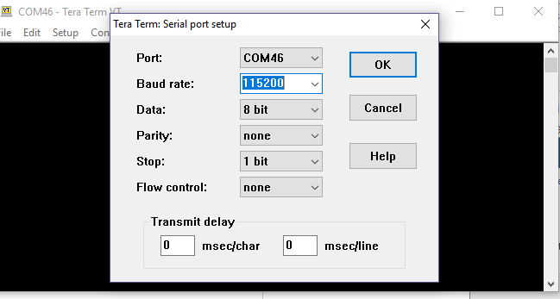

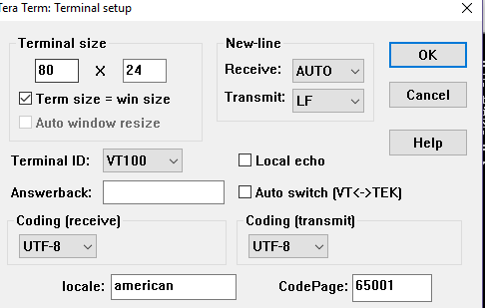

1. Click on Black Button of the Discovery board

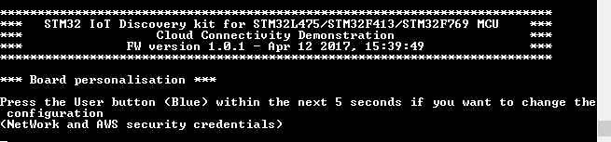

1. Click on Blue button. It will prompt you for configuring the Wifi credential.type y and enter.

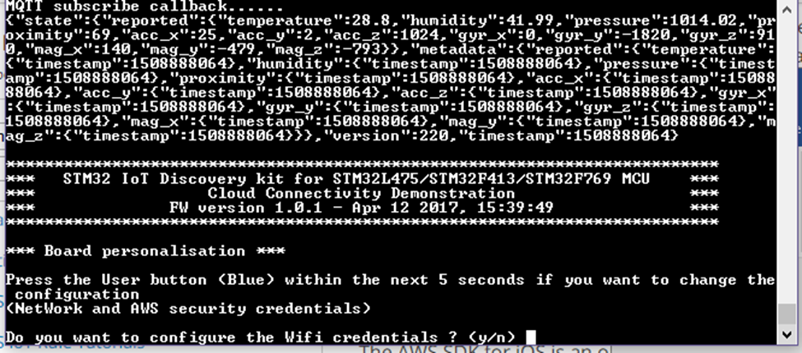

1. It will ask for SSID. Enter the Wifi name and connect with the mobile hotspot.

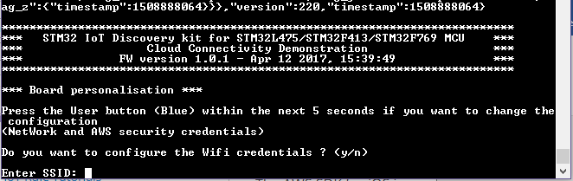

1. Enter the security type and wifi password, if security type is not open.

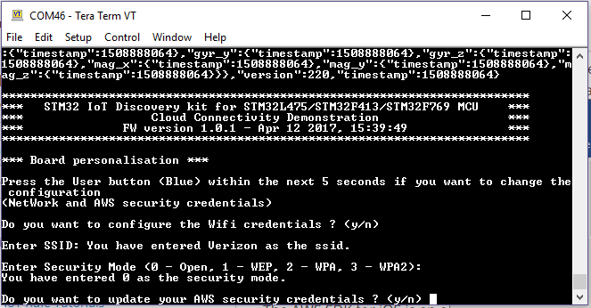

1. It will ask for server address. Go to AWS IoT🡪Interact and it will show as per the below screenshot.

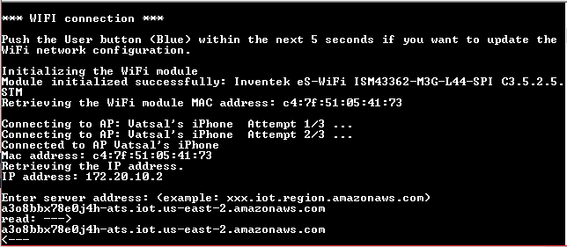

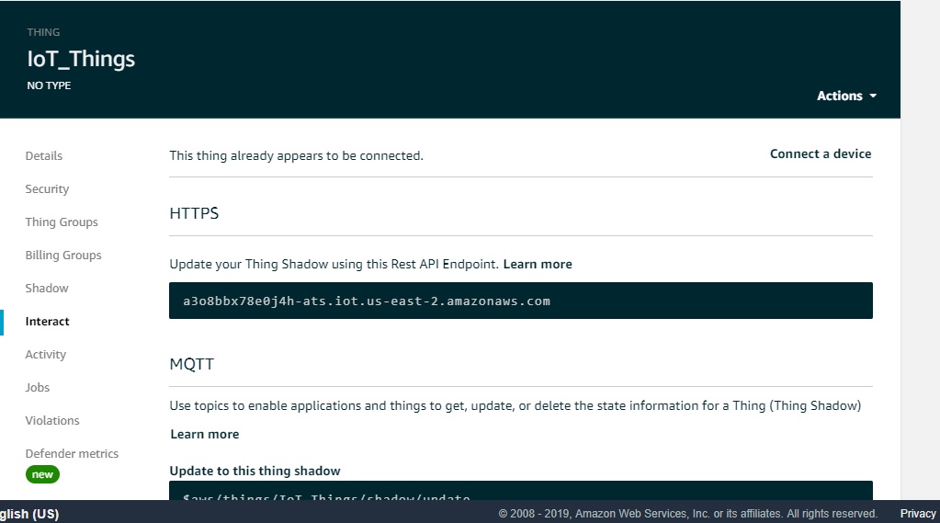

1. Enter the device name. Write the thing name you had created earlier.

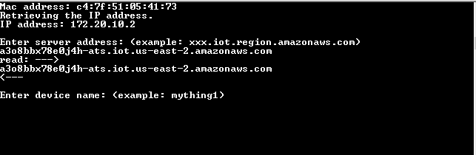

1. It will ask for root CA. Enter the root CA from the root certificate file downloaded earlier. Enter the RSA 2048 bit key: Amazon Root CA 1 instead of VeriSign Class 3 Public Primary G5 root CA certificate.

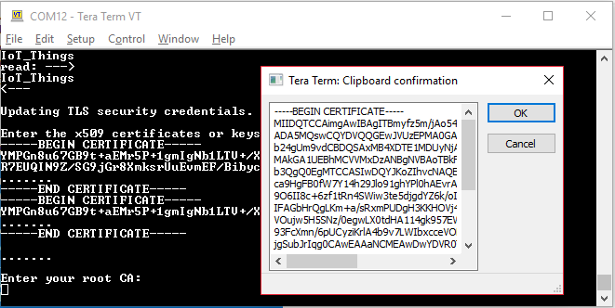

1. It will ask for device’s certificate. Enter the key from .perm.cert file.

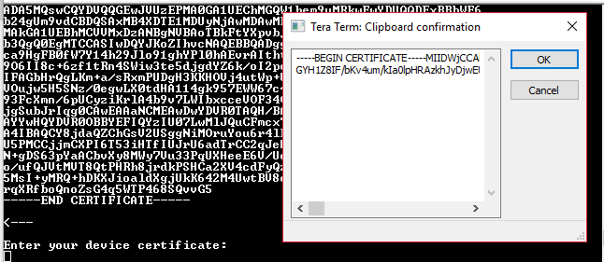

1. It will ask for private key. Enter the private key downloaded earlier.

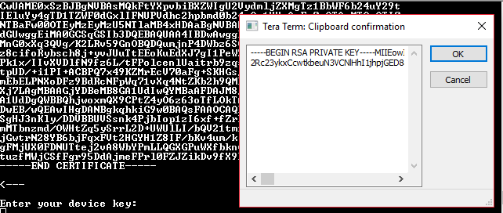

1. Once done, it will start send the sensor data to the AWS cloud as below

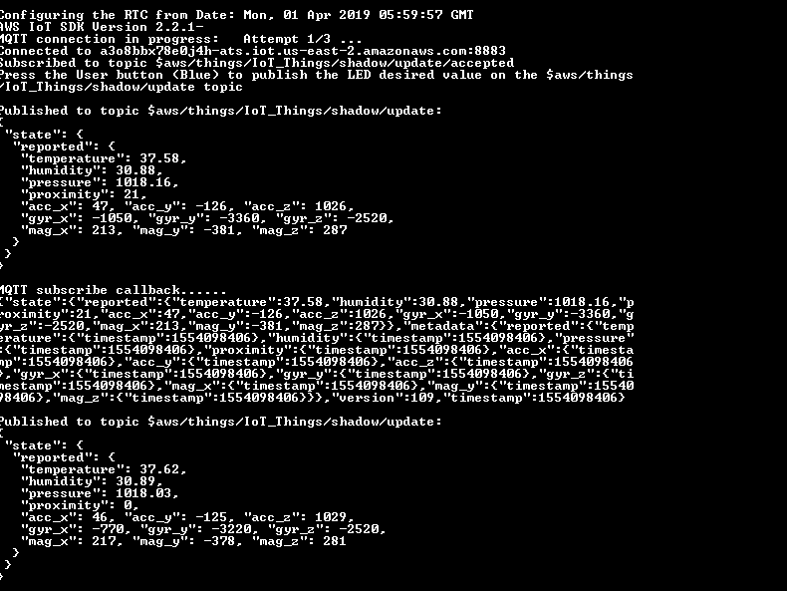

1. Verify the data by going to AWS IoT🡪Shadow

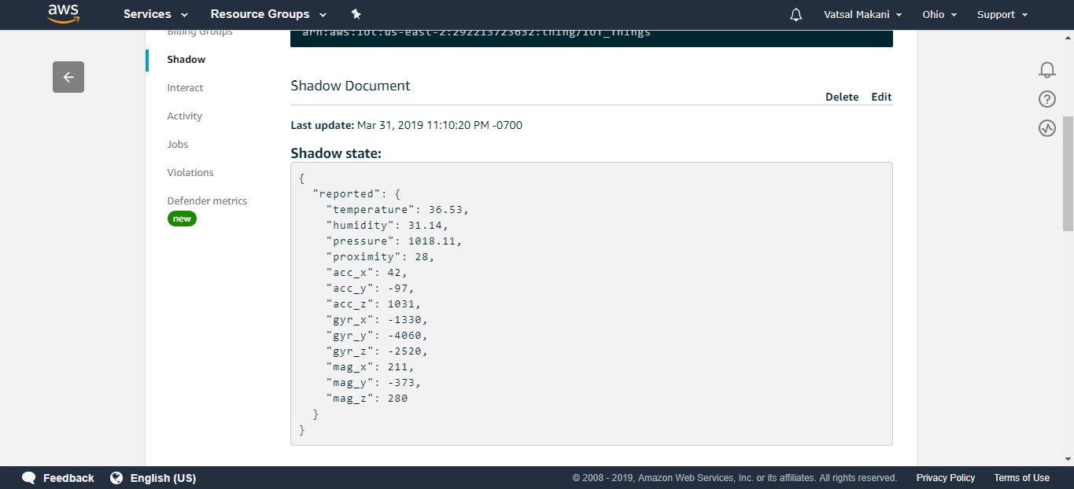

By these steps, I was able to send sensor data to AWS IoT.

**WIFI MODULE IN SJGATEWAY BOARD**

* First step was to understand the schematic and interconnection of wifi module with ST Microcontroller—Ref: SJGATEWAYV1.pdf schematic file
* By this, we were able to figure out that UART3 was used with wifi module and to check the output at the terminal window, we need to send the data over UART1
* Currently I am working with Jay and Dhananjai to transfer the data from UART3 to UART1, and so far we were able to transfer the data.

Troubleshooting 1

* Wifi module is unable to send the data since there is a problem for wifi initialization when we run the STM32 demo code.
* **So far, we are trying to update the wifi firmware using the instructions mentioned in Inventek firmware README.md file and there is a problem loading the firmware using STMFlashLoader software since it is unable to detect the COM port.**
* **We verified the steps by implementing the same steps in STM IoT Discovery kit and we can update the wifi firmware successfully.**

Troubleshooting 2:

* I tried to upload the Mbed sample code in SJGateway board for Inventek wifi : <https://os.mbed.com/teams/ST/code/mbed-os-example-wifi/?platform=ST-Discovery-L475E-IOT01A>
* As per instructions, I configured the .json file and build using online compiler and downloaded the code on the board. **It is unable to scan nearby wifi networks.**

Troubleshooting 3:

* Currently I am trying to use AT commands as per Inventek Wifi Module User Manual and trying to send the data from Teraterm (UART 1) to UART 3.

**WHEELCHAIR PROJECT**

We have translated the Arduino code and included the STM demo code and currently we are testing the PWM code with the LED. Later we are planning to implement the final code in the wheelchair motor with the help of joystick.